CHALLENGE ON AWS
- Launch one EC2 instance using Amazon Linux 2.
We are configuring inbound ports such as
Security Group Configuration
- Allow the following inbound ports:
- SSH → 22
- HTTP → 80
- Custom TCP → 8080 (Jenkins)
- Custom TCP → 8081 (Apache)
- Custom TCP → 8082 (nginx)
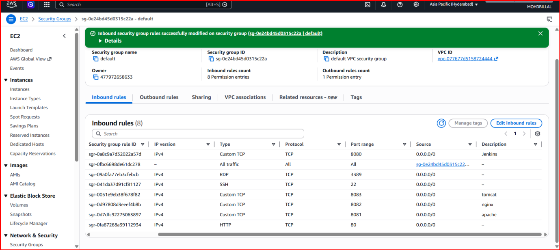

- Install Docker
- sudo dnf install docker -y
- sudo systemctl start docker
- sudo systemctl enable docker
- docker –version

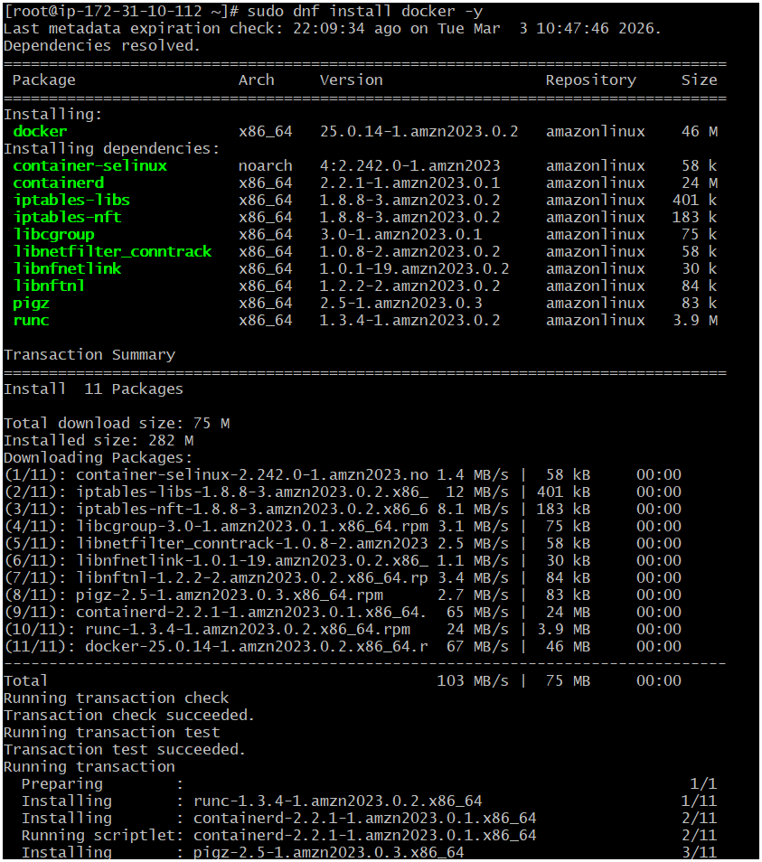
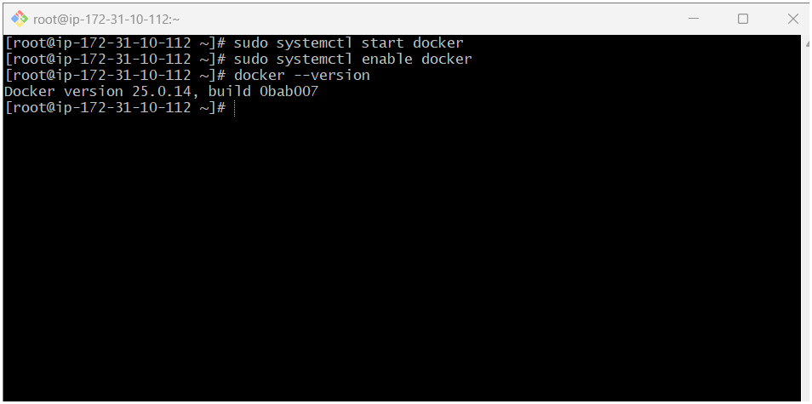
- Install Jenkins.
- sudo dnf install java-17-amazon-corretto –y
- java –version
- sudo wget -O /etc/yum.repos.d/jenkins.repo \
- https://pkg.jenkins.io/redhat-stable/jenkins.repo
- sudo rpm --import https://pkg.jenkins.io/redhat-stable/jenkins.io-2023.key
- sudo dnf makecache
- sudo dnf install jenkins –y
- sudo systemctl enable jenkins
- sudo systemctl start jenkins
- sudo systemctl status Jenkins
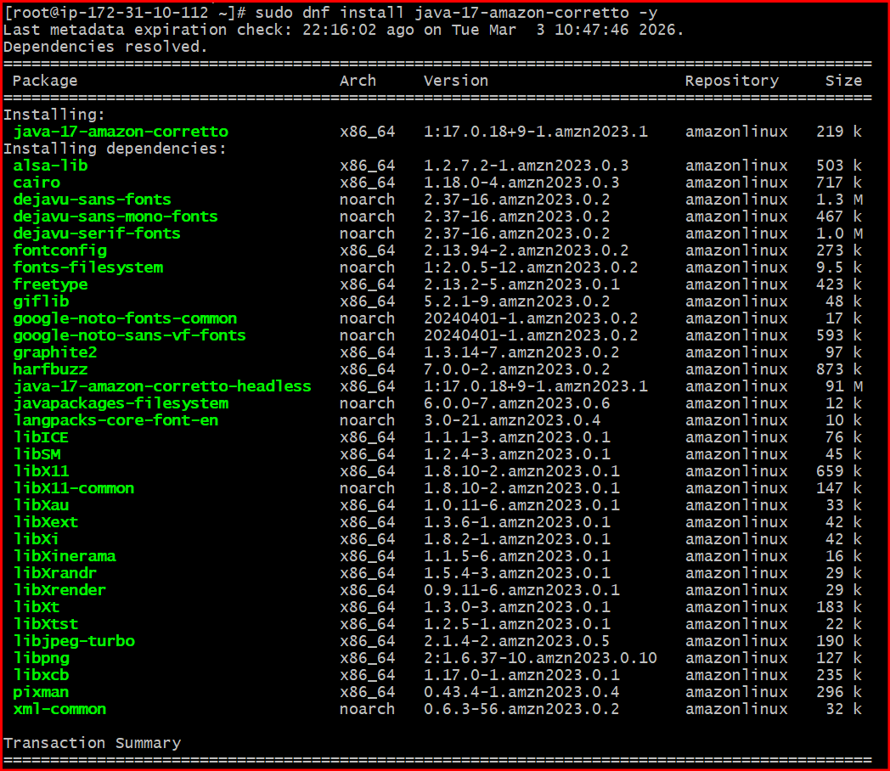

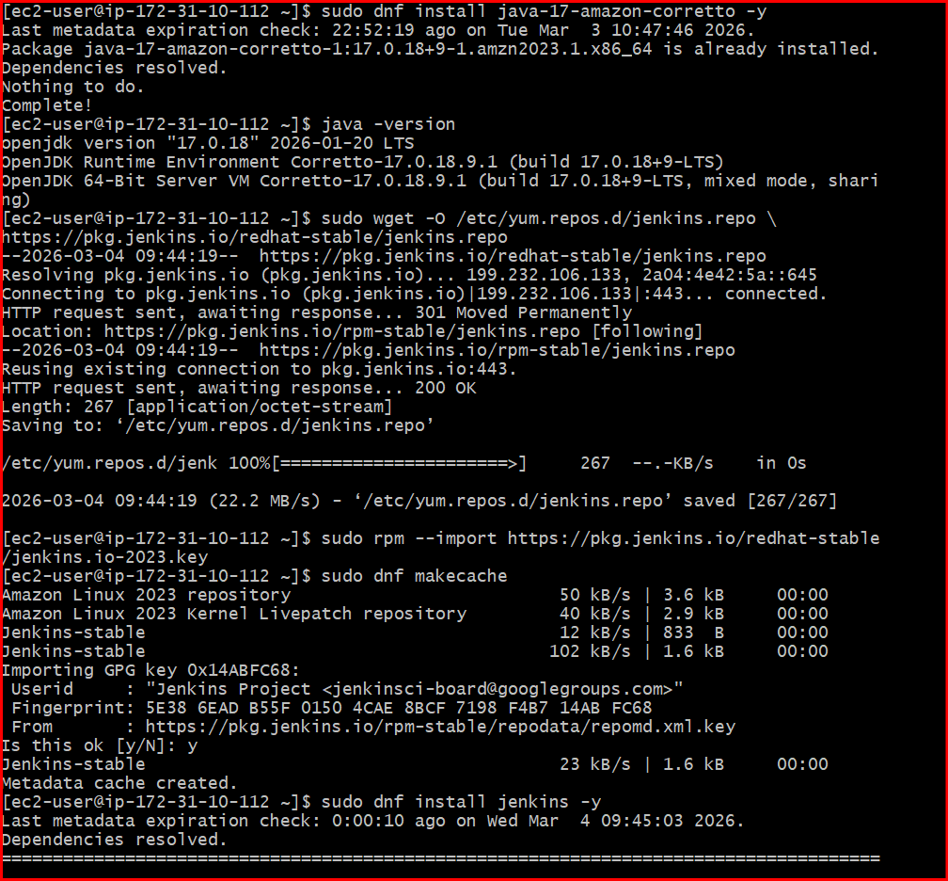
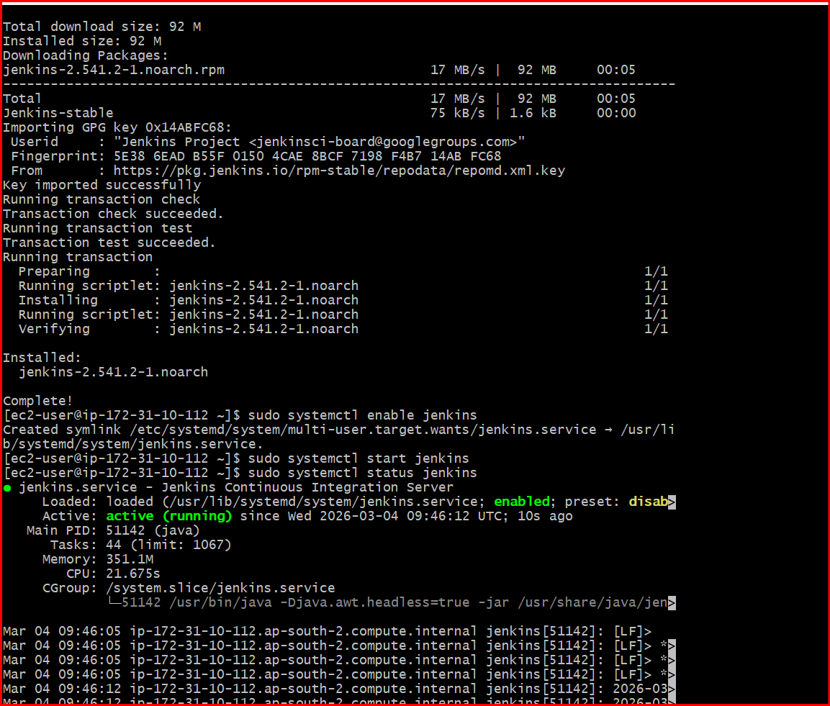
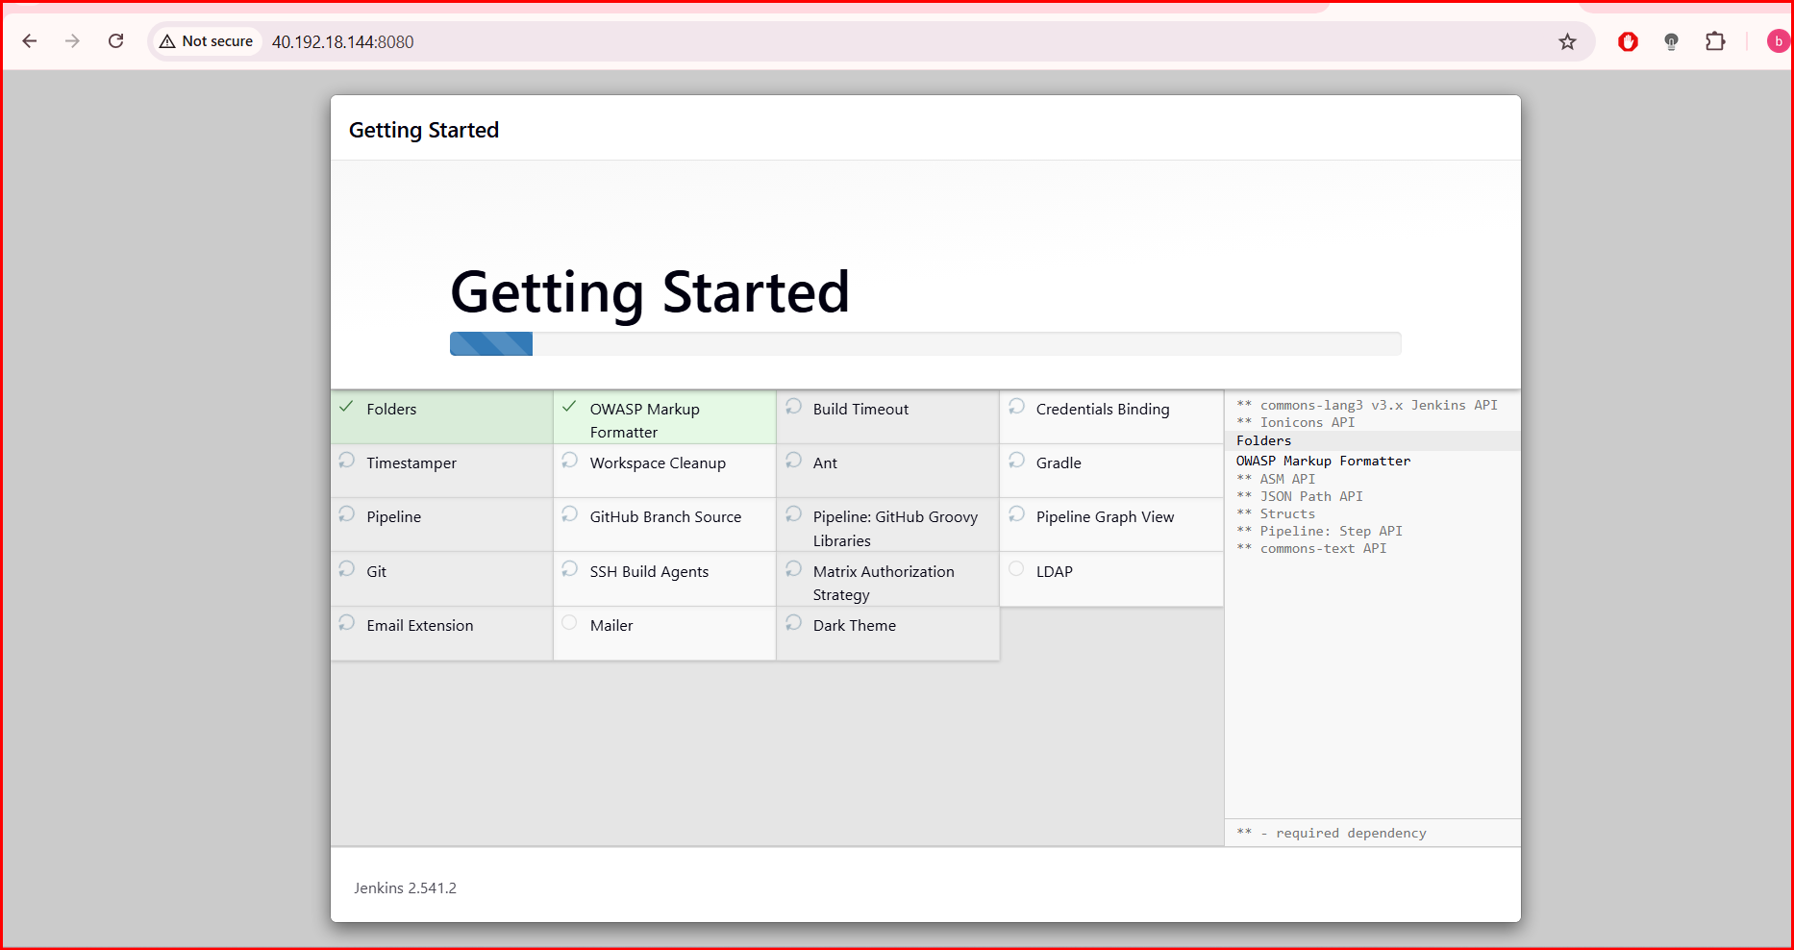
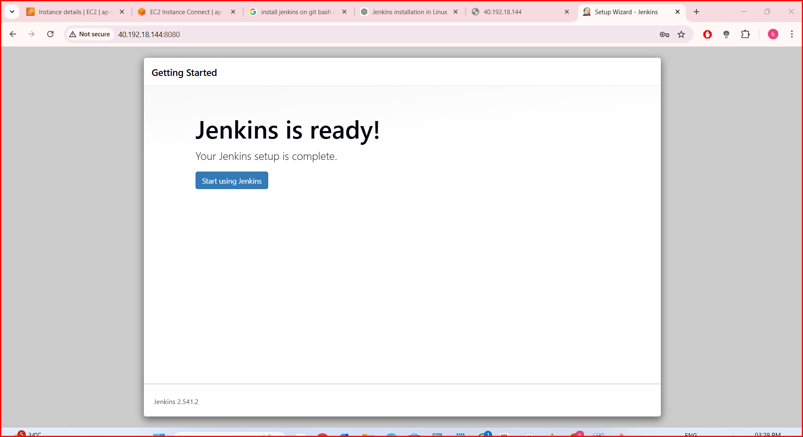
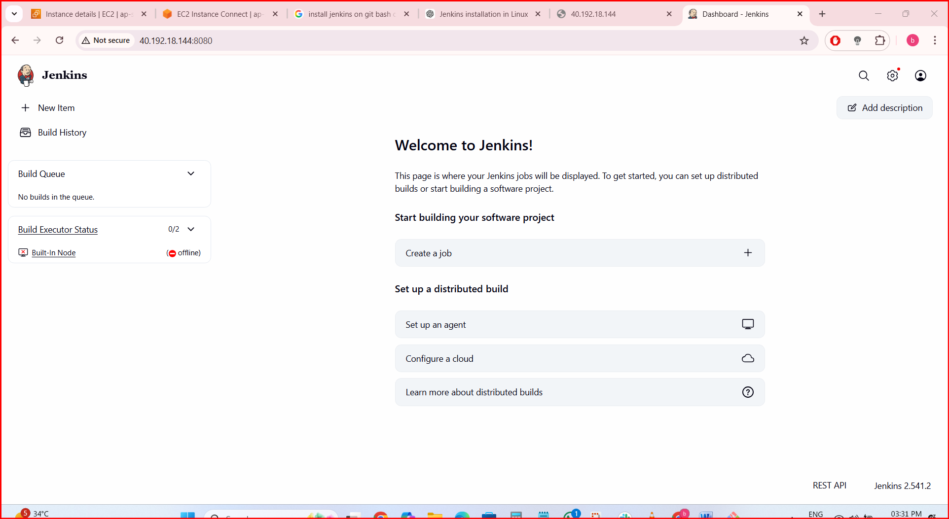
- Install Apache.
- sudo dnf install httpd –y
- sudo systemctl start httpd
- sudo systemctl enable httpd
- sudo systemctl status httpd
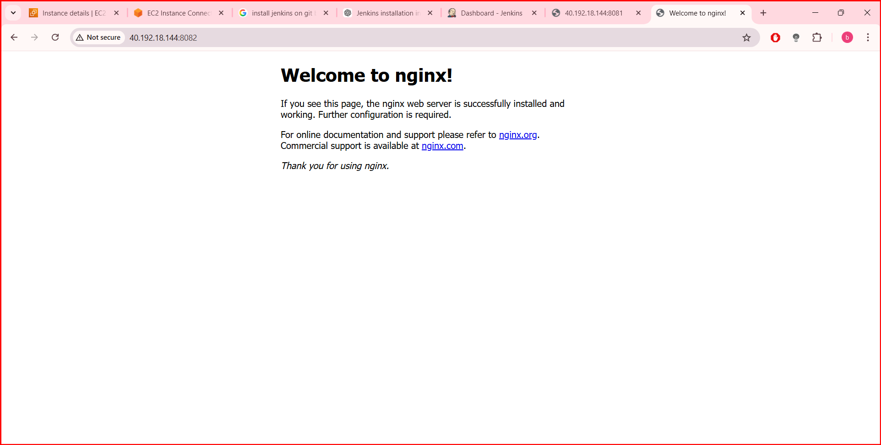
- Install Nginx.
- sudo dnf install nginx –y
- sudo nano /etc/nginx/nginx.conf
- listen 80 to
- listen 8082;
- sudo systemctl start nginx
- sudo systemctl enable nginx
- sudo systemctl status nginx


